**BUAN 6312.004**

Applied Econometrics and Time Series Analysis

Spring 2019

**Research Question**

Do shall-issues law reduce crime or not?

**Mentored By**

Dr. Moran Blueshtein

**Prepared By**

Pavan Sai Krishna Gorantla

Nishant Mathew

Vishal Taneja

Aarya

**Contents**

1. Abstract …………………………………….……………………….….…………………………………… 3
2. Data Description ……………………………………………….………………………………………… 4
   1. Trends in Violent Crimes .…………....…………..…………………….…………………. 5
   2. Trends in Robberies ……………………….………..………………………………………… 6
   3. Trends in Murders ……………………………..……..…………………………………..….. 7
   4. States with Shall Law …………………………………….…..………………………………. 8
   5. Skewness …………………………………….………………..………………………………… 10
   6. Correlation …………………………………………………….………………….……………. 11
3. Regression Models ….…………….………………………………….……..………………..….…. 12
   1. Violent Crime Rate .……………………..…………………..…………….……………….. 12
   2. Robbery Rate …………………………………………………….………………………….… 17
   3. Murder Rate ………………………………………………………..………………………….. 22
4. Models Interpretation …………………………………………………………………………….… 27
   1. Conclusions ………..…………………………………………………………………………… 27
   2. Limitations …..……….……………………………………………………………….……….. 27
5. References …………………………………………………………………………………….…………. 28
6. Abstract

The impact of guns on crime in America has triggered lot of public debate. Many strongly believe that state laws enabling citizens to carry concealed handguns had reduced crime. According to this view, gun control laws take away guns from law-abiding citizens, while would-be criminals ignore those leaving potential victims defenseless. Following this view, National Rifle Association (NRA) and many politicians across country advance the cause of greater freedom to carry guns.

As a result, many states in United States have passed **right-to-carry laws** (aka **shall-issue laws**). A shall-issue law is one that requires the governments to issue permits for carrying concealed handgun to any applicant who meets the necessary criteria. These criteria are:

1. Applicant must be an adult
2. Applicant must not have a significant criminal record
3. Applicant must not have a history of any mental illness
4. Applicant must successfully complete a course in firearms safety training (if required)

If these criteria are met, the granting authority has no discretion in the awarding of the licenses, and there is no requirement for the applicant to demonstrate "good cause".

In this study, we focus on the effects of shall-issue laws using historical data of 51 states followed over a period of 23 years. We run various models to interpret the trends showing the variation in crime rates before and after the introduction of the shall-law along with the effects of other factors like income, population, proportion of population that is white, black and young males. From the results we can infer that there is no significant effect of shall-issue law on crime rates.

1. Data Description

We have balanced panel data available for 51 US states (including the District of Columbia), from 1977 to 1999 having data about violent crime rate (vio), robbery rate (rob), murder rate (mur), shall (shall-law indicator), incarceration rate (incarc_rate), per capita income (avginc), population (pop), population density (density), proportion of male youth aged 10 to 29 (pm1029), proportion of white adults aged 10 to 64 (pw1064), proportion of black adults aged 10 to 64 (pb1064). Following are the details of all variables available for 51 US states from 1977 to 1999.

|  |  |
| --- | --- |
| **Variable** | **Definition** |
| *vio* | violent crime rate (incidents per 100,000 members of the population) |
| *rob* | robbery rate (incidents per 100,000 members of the population) |
| *mur* | murder rate (incidents per 100,000 members of the population) |
| *shall* | = 1 if the state has a shall-carry law in effect in that year  = 0 otherwise |
| *incarc_rate* | incarceration rate in the state in the previous year (sentenced  prisoners per 100,000 residents; value for the previous year) |
| *density* | population per square mile of land area, divided by 1000 |
| *avginc* | real per capita personal income in the state, in thousands of dollars |
| *pop* | state population, in millions of people |
| *pm1029* | percent of state population that is male, ages 10 to 29 |
| *pw1064* | percent of state population that is white, ages 10 to 64 |
| *pb1064* | percent of state population that is black, ages 10 to 64 |
| *stateid* | ID number of states (Alabama = 1, Alaska = 2, etc.) |
| *year* | Year (1977-1999) |

* 1. Trends in Violent Crimes

**Violent Crime Rate for 51 States: State 11 has highest number of incidents and seems as outlier**

**Graph 2.1.1 - Violent Crime Rate for 51 States (Violent Crime Incidents per 100,000 Members of Population v/s Years)**

**Violent Crime Rate for 23 Years: State 11 has highest number of incidents and seems as outlier**

**Graph 2.1.2 - Violent Crime Rate for 23 Years (Violent Crime Incidents per 100,000 Members of Population v/s States)**

* 1. Trends in Robberies

**Robbery Rate for 51 States: State 11 has highest number of incidents and seems as an outlier**

**Graph 2.2.1 - Robbery Rate for 51 States (Robbery Incidents per 100,000 Members of Population v/s Years)**

**Robbery Rate for 23 Years: State 11 has highest number of incidents and seems as an outlier**

**Graph 2.2.2 - Robbery Rate for 23 Years (Robbery Incidents per 100,000 Members of Population v/s States)**

* 1. Trends in Murders

**Murder Rate for 51 States: State 11 has highest number of incidents and seems as an outlier**

**Graph 2.3.1 - Murder Rate for 51 States (Murder Incidents per 100,000 Members of Population v/s Years)**

**Murder Rate for 23 Years: State 11 has highest number of incidents and seems as an outlier**

**Graph 2.3.2 - Murder Rate for 23 Years (Murder Incidents per 100,000 Members of Population v/s States)**

* 1. States with Shall Law

**Number of States with Shall Law: 22 states do not have shall-law in entire observation period**

**Graph 2.4.1 - Shall Law States (Number of States v/s Start Year of Shall Law)**

**Violent Crime Rate in Shall Law States: Early shall-law adopting states have less violent crimes**

**Graph 2.4.2 - Average Violent Crime Rate in States with Shall Law and without Shall Law**

**Robbery Rate in Shall Law States: Early shall-law adopting states have less robbery incidents**

**Graph 2.4.3 - Average Robbery Rate in States with Shall Law and without Shall Law**

**Murder Rate in Shall Law States: Early shall-law adopting states have less murder incidents**

**Graph 2.4.4 - Average Murder Rate in States with Shall Law and without Shall Law**

* 1. Skewness

All 3 dependent variables (Violent Crime Rate, Robbery Rate and Murder Rate) are highly skewed due to outlier state 11, and hence it is better to use their logarithmic values to reduce skewness.

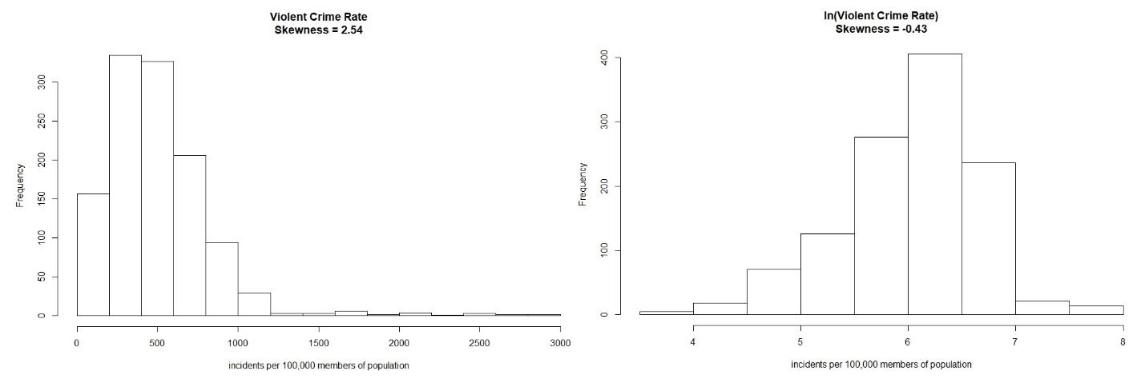

**Graph 2.5.1 - Frequency Distribution of Violent Crime Rate (skewness = 2.54) and its Natural Logarithm (skewness = -0.43)**

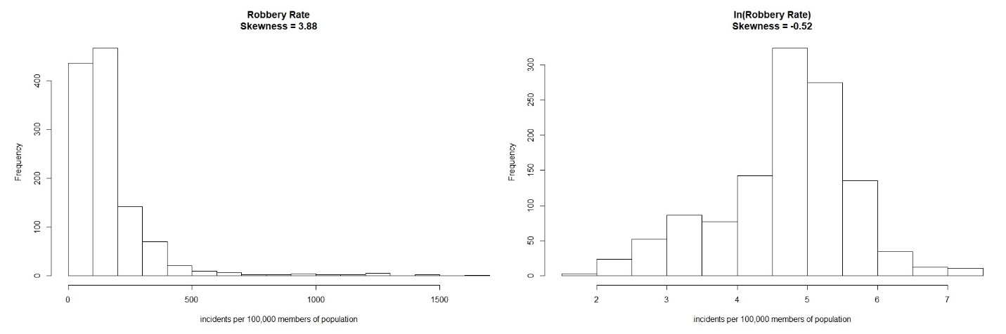

**Graph 2.5.2 - Frequency Distribution of Robbery Rate (skewness = 3.88) and its Natural Logarithm (skewness = -0.52)**

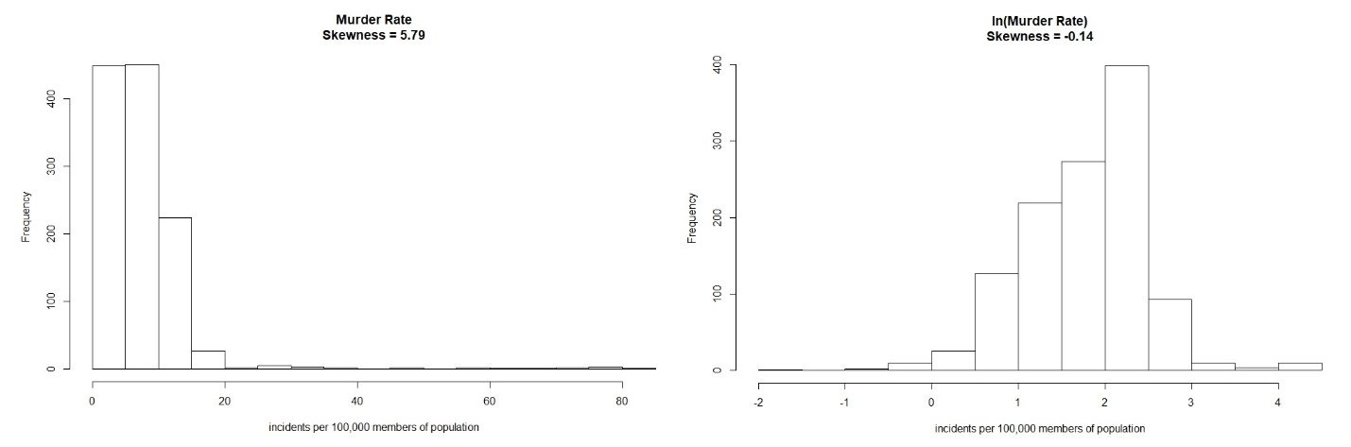

**Graph 2.5.2 - Frequency Distribution of Murder Rate (skewness = 5.79) and its Natural Logarithm (skewness = -0.14)**

* 1. Correlation

Following is correlation plot among independent variables and dependent variables logarithms. Grey color box indicates a positive correlation and Red color box indicates a negative correlation.

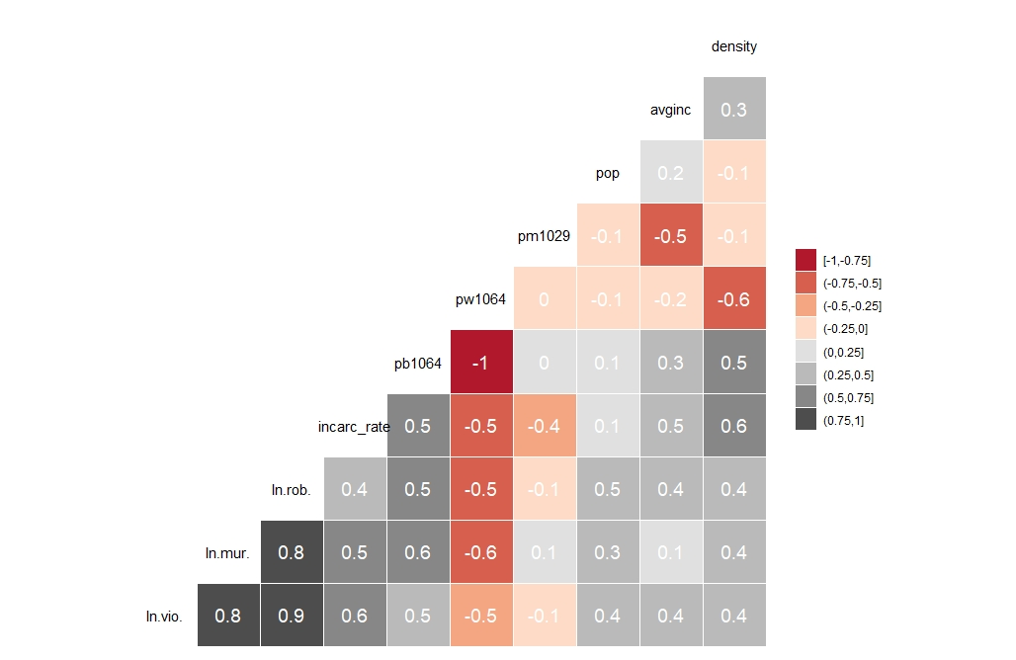

**Graph 2.6 - Correlation between all Independent Variables and Logarithms of Dependent Variables**

Violent Crime Rate, Robbery Rate and Murder Rate are highly correlated as we expect in general. The variables *density*, *pb1064*, *pw1064* and *incarc_rate* have moderate correlation with others. From the above correlation matrix, we can see that the variables *pb1064* and *pw1064* have very high negative correlation with each other as expected since both variables are complementary. The remaining variables *pm1029*, *pop* and *avginc* do not have significant correlation with others.

1. Regression Models
   1. Violent Crime Rate

**Linear Regression:**

We start with a normal linear regression without any corrections for the robust standard errors

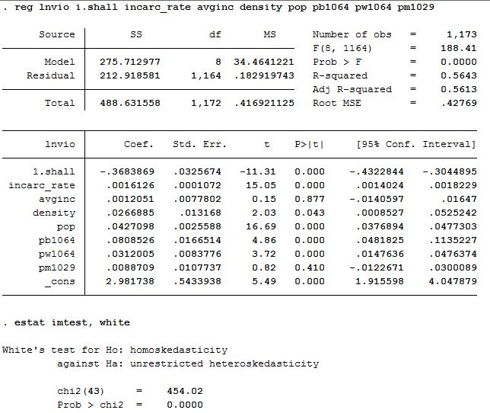

White test revealed that residuals are heteroskedastic, hence we estimate robust standard errors

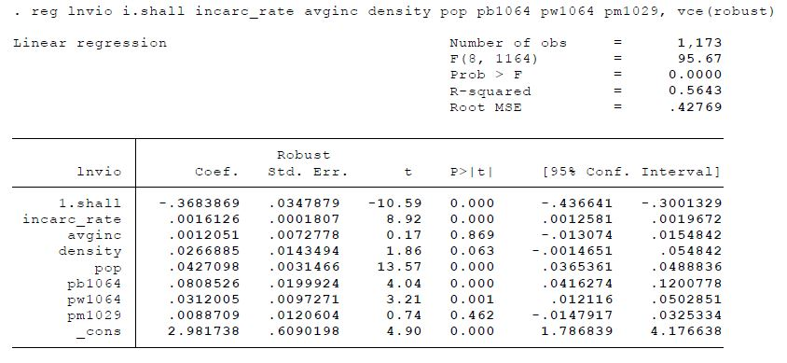

**Pooled OLS (with robust errors):**

Pooled OLS with robust standard errors for heteroskedasticity and auto correlation within states

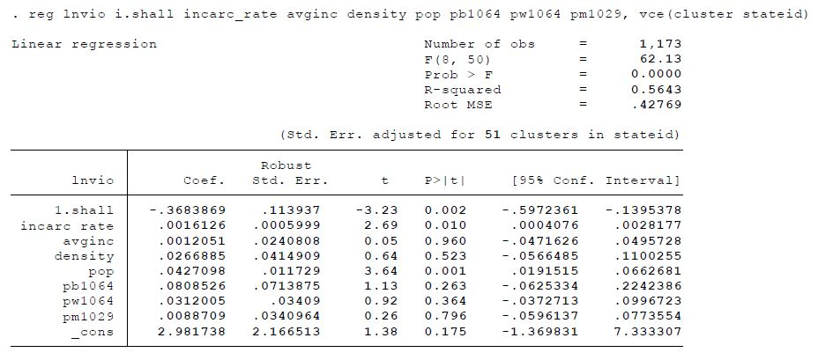

**Model Interpretations:**

* According to linear and pooled models, all variables except *shall* account for raising crimes
* States with shall-law in effect have 36.84% less violent crimes than states without shall-law
* In pooled model, variables with 1% significance are *shall*, *incarceration rate* and *population*

**Fixed Effects (without robust errors):**

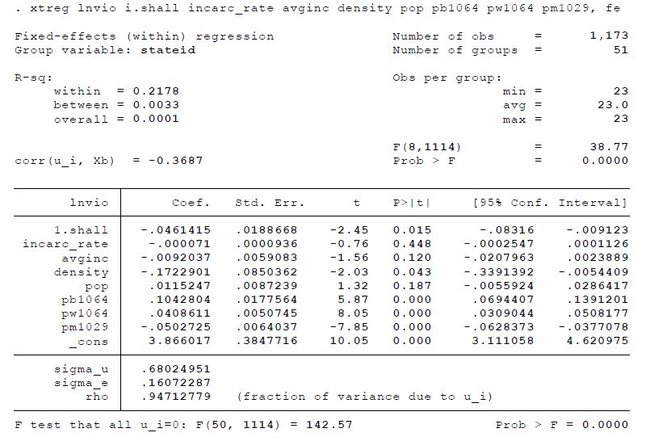

**Random Effects (without robust errors):**

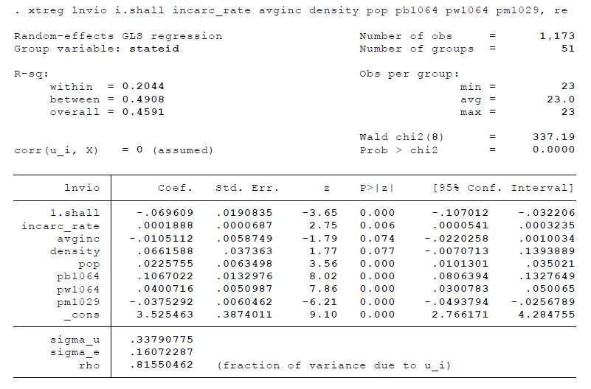

**Huasman Test:**

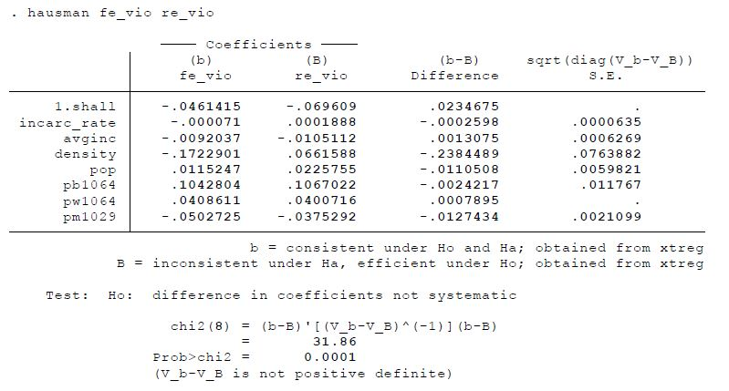

**Model Interpretations:**

* From above test, we say that estimates of fixed and random effects are significantly different
* Both Fixed/Random effects indicate that shall-law reduces violent crimes with 5% significance

**Entity Fixed Effects (with robust errors):**

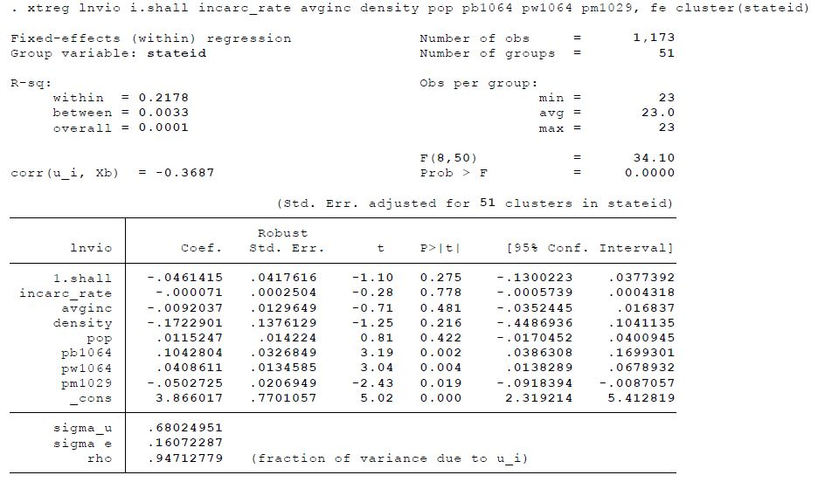

**Entity Fixed and Time Fixed Effects (with robust errors):**

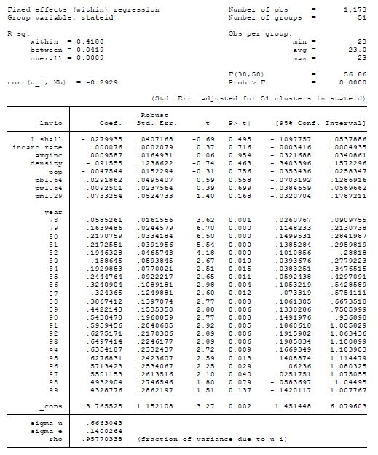

**Time Fixed Effects Significance:**

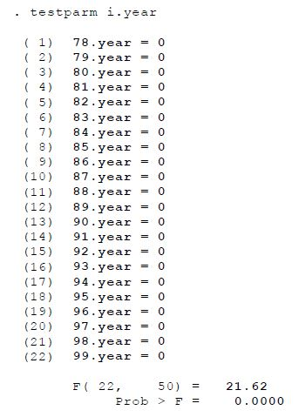

**Random Effects (with robust errors):**

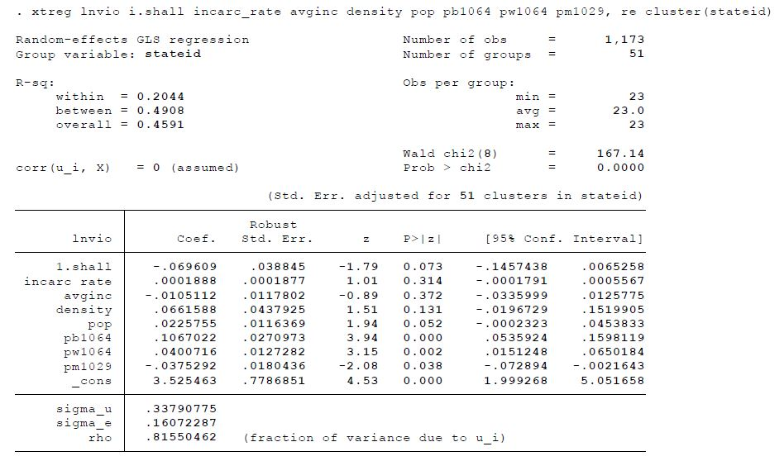

**Model Interpretations:**

* The joint significance test in Time Fixed model shows that at least one estimate is significant
* After obtaining robust errors, both models estimates for shall-law became insignificant at 5%
  1. Robbery Rate

**Linear Regression:**

We start with a normal linear regression without any corrections for the robust standard errors

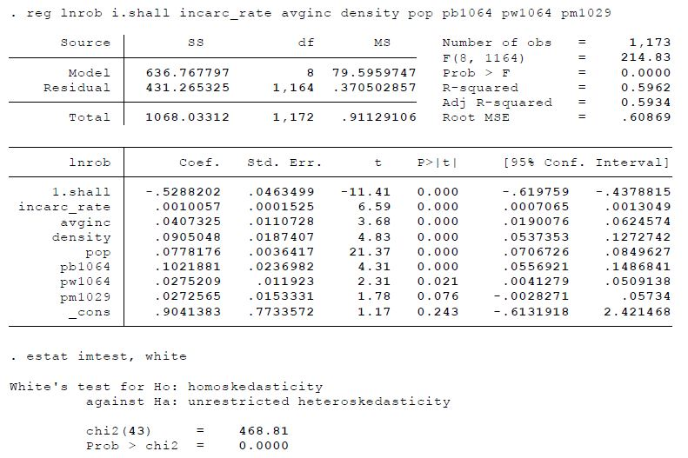

White test revealed that residuals are heteroskedastic, hence we estimate robust standard errors

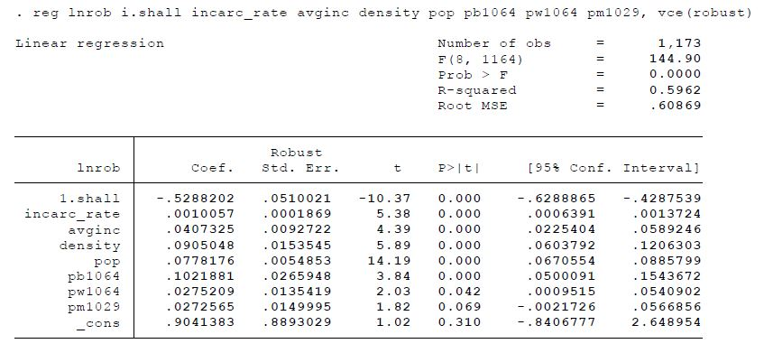

**Pooled OLS (with robust errors):**

Pooled OLS with robust standard errors for heteroskedasticity and auto correlation within states

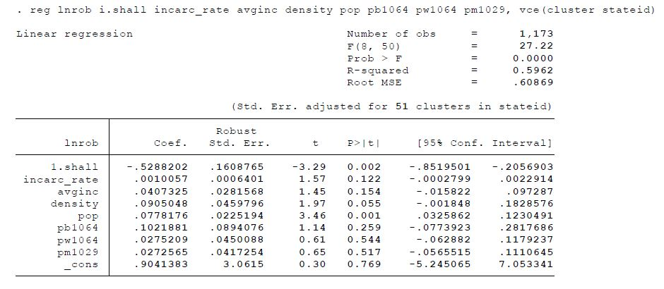

**Model Interpretations:**

* According to linear & pooled models, all variables except *shall* account for more robberies
* States with shall-law in effect have 52.88% less robberies than the states without shall-law
* In the pooled model, variables with 1% significance are only *shall* and *population* variables

**Fixed Effects (without robust errors):**

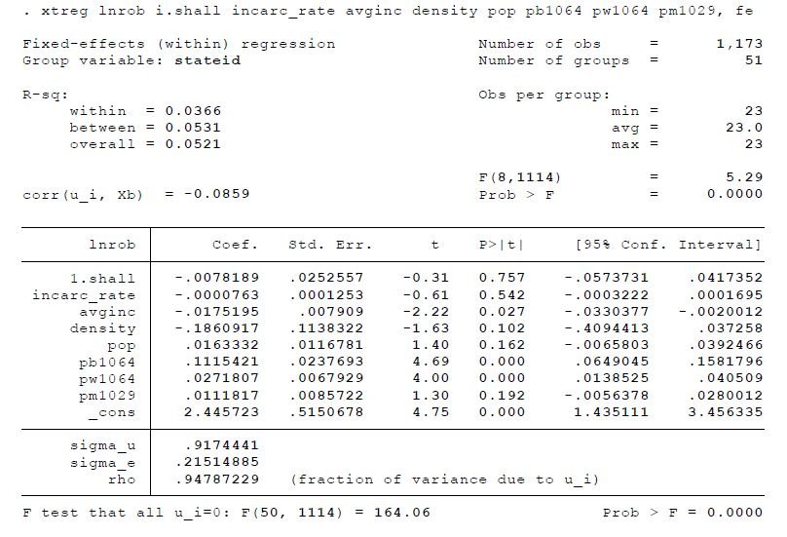

**Random Effects (without robust errors):**

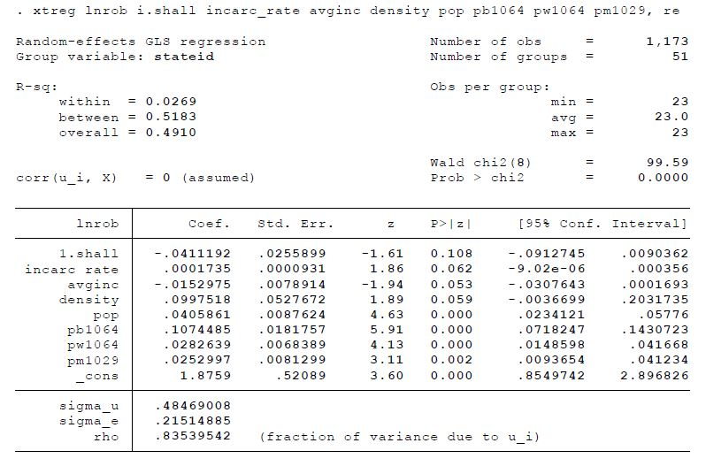

**Huasman Test:**

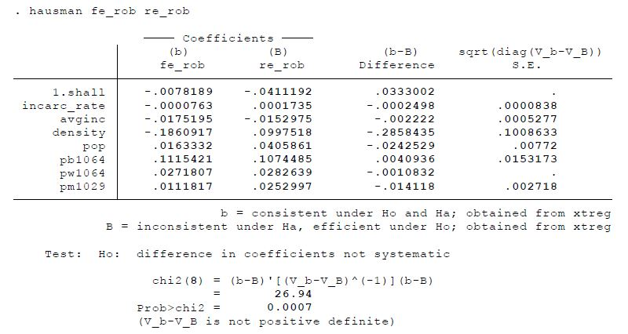

**Model Interpretations:**

* From above test, we say that estimates of fixed and random effects are significantly different
* Both Fixed/Random effects indicate shall-law reduce robberies but its estimate is insignificant

**Entity Fixed Effects (with robust errors):**

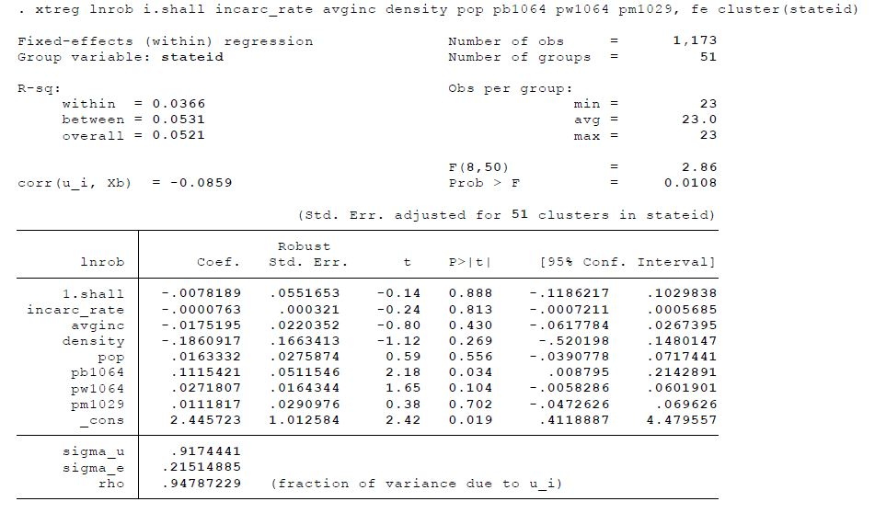

**Entity Fixed and Time Fixed Effects (with robust errors):**

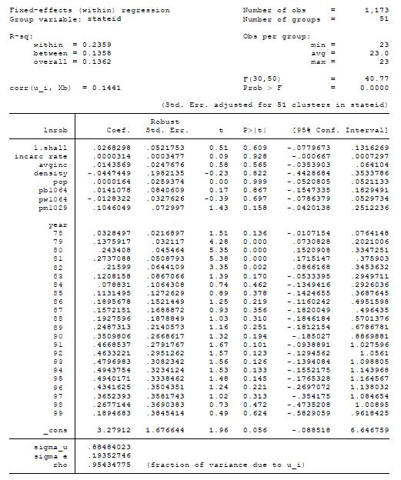

**Time Fixed Effects Significance:**

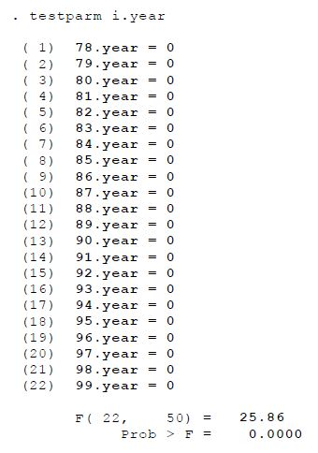

**Random Effects (with robust errors):**

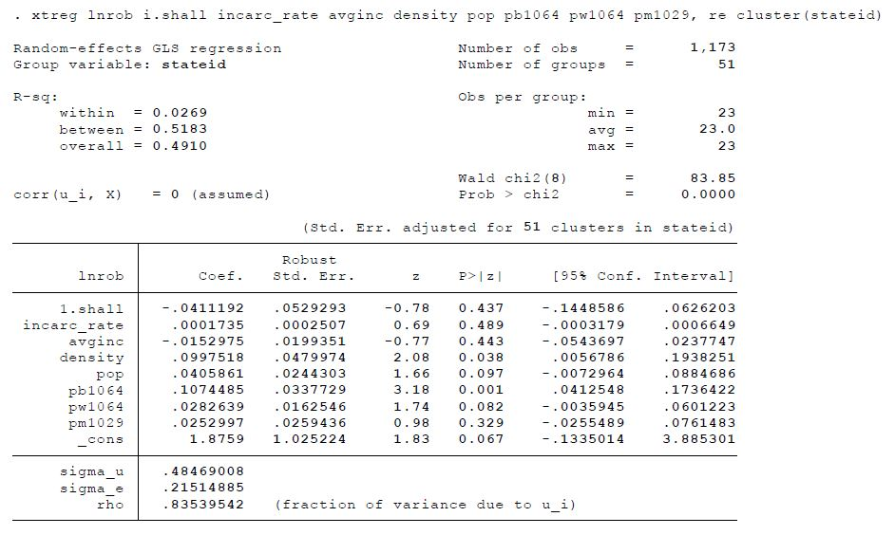

**Model Interpretations:**

* The joint significance test in Time Fixed model shows that at least one estimate is significant
* After obtaining robust errors, both models estimates for shall-law became insignificant at 5%
  1. Murder Rate

**Linear Regression:**

We start with a normal linear regression without any corrections for the robust standard errors

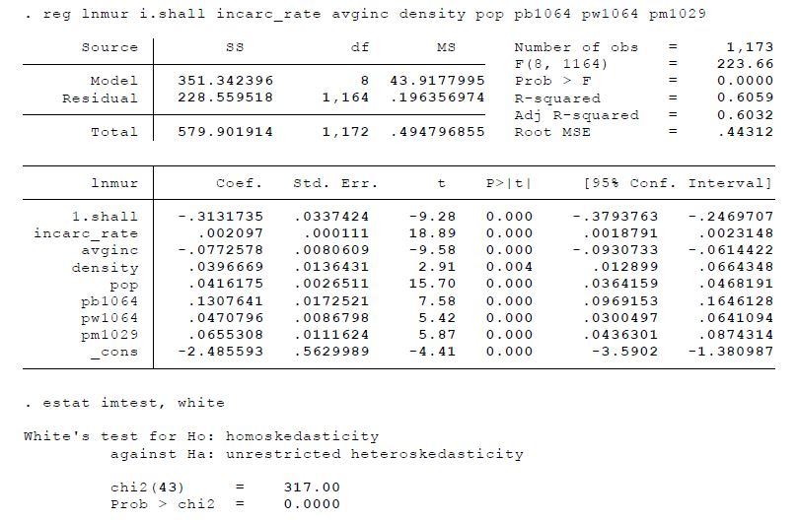

White test revealed that residuals are heteroskedastic, hence we estimate robust standard errors

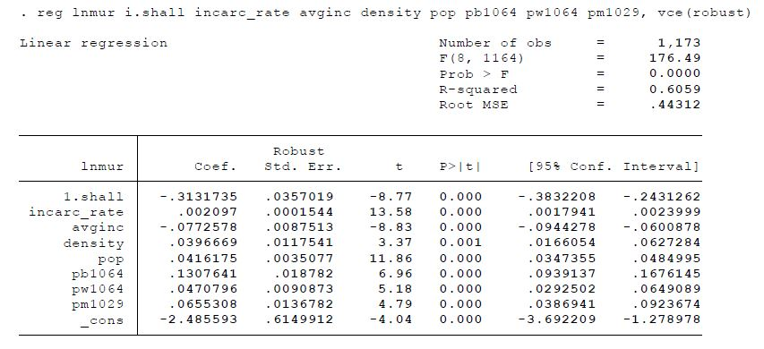

**Pooled OLS (with robust errors):**

Pooled OLS with robust standard errors for heteroskedasticity and auto correlation within states

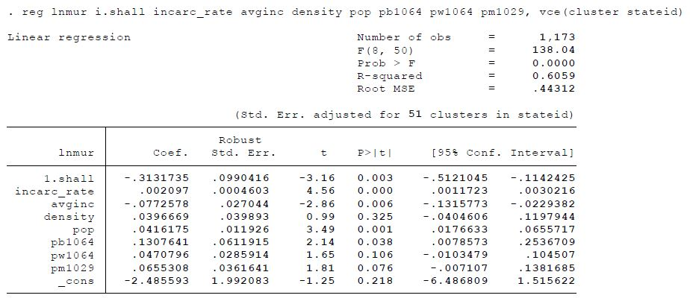

**Model Interpretations:**

* According to linear & pooled models, all variables except *shall* & *avginc* increase murders
* States with shall-law in effect have 31.32% less murders than the states without shall-law
* In pooled model, all the variables except density, pw1064 & pm1029 are significant at 5%

**Fixed Effects (without robust errors):**

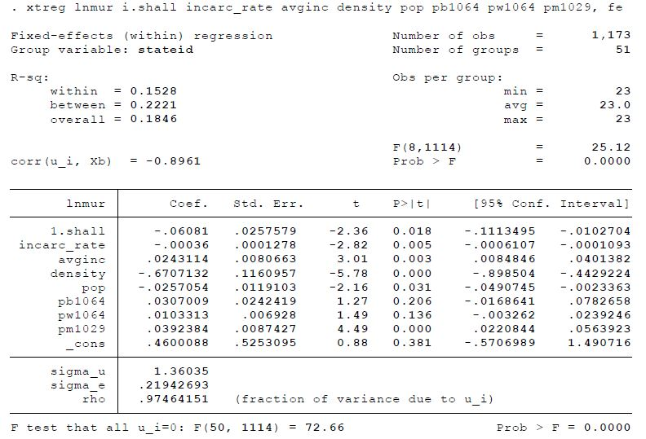

**Random Effects (without robust errors):**

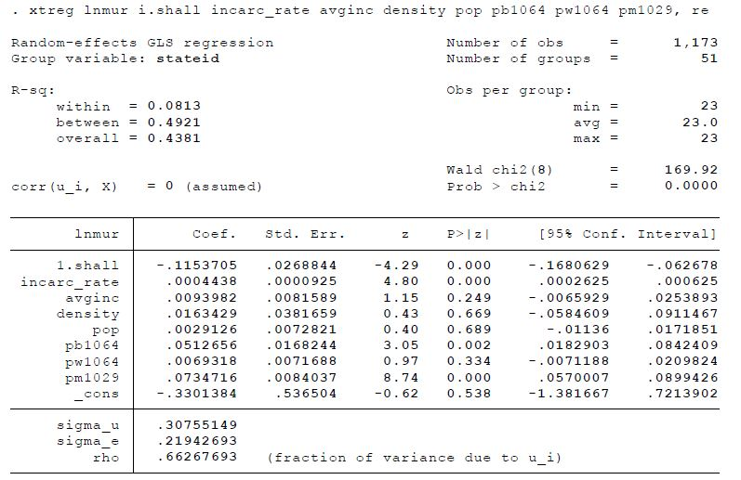

**Huasman Test:**

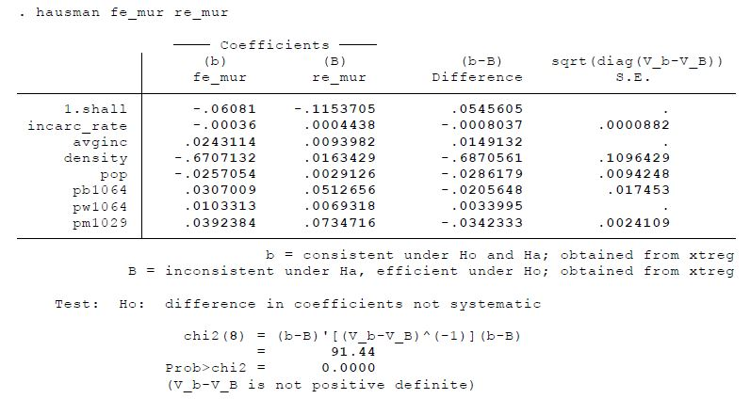

**Model Interpretations:**

* From above test, we say that estimates of fixed and random effects are significantly different
* Both Fixed/Random effects indicate that shall-law reduces murder rates with 5% significance

**Entity Fixed Effects (with robust errors):**

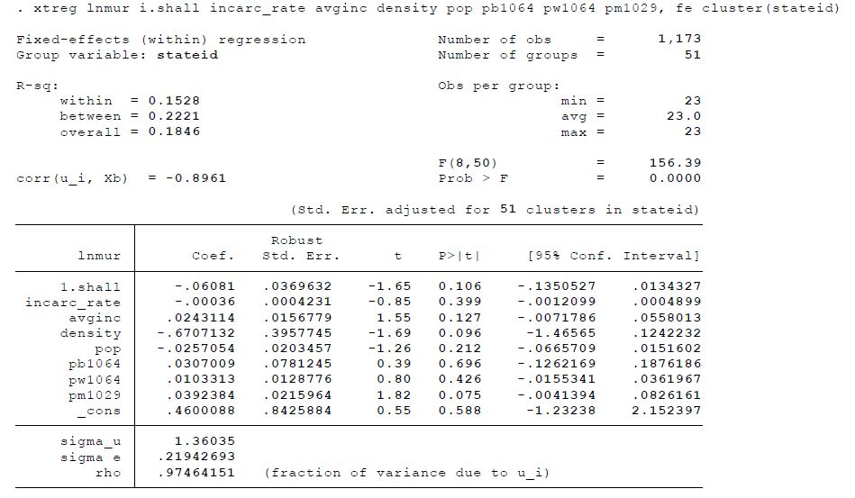

**Entity Fixed and Time Fixed Effects (with robust errors):**

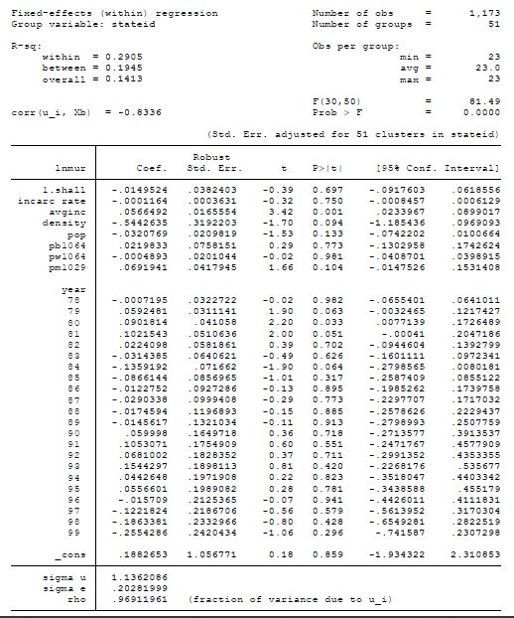

**Time Fixed Effects Significance:**

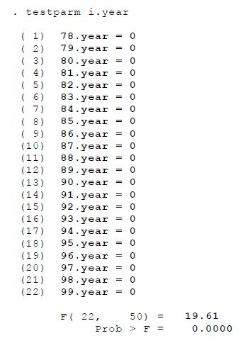

**Random Effects (with robust errors):**

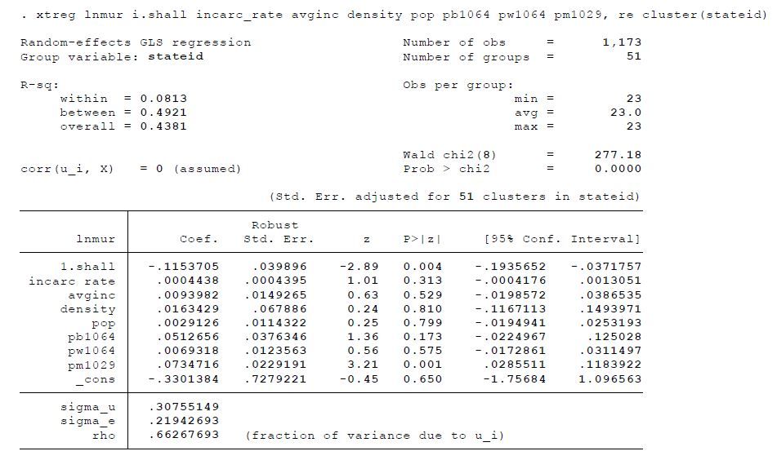

**Model Interpretations:**

* The joint significance test in Time Fixed model shows that at least one estimate is significant
* After obtaining robust errors, fixed effects estimates for shall-law became insignificant at 5%

1. Models Interpretation
   1. Conclusions

**Pooled OLS: According to Pooled OLS, states with shall-law in effect have 37% less crime rate, 53% less robbery rate and 31% less murder rate when compared to states without shall-law.** Pooled OLS model does not account for entity fixed effects or time fixed effects and treats panel data as cross-sectional data. Hence, pooled regression model is not the best model. Estimated coefficients of *shall* variable in pooling models shows a large and significant effect on violent crime rate, murder rate and robbery rate. However, we cannot rely on this model and these effects disappear in fixed effects models as it accounts for the variations within states and time.

**Fixed Effects: According to both Fixed Effects models (Entity Fixed and Entity-Time Fixed), the estimates for shall variable are insignificant and does not give enough evidence that shall-law has significant effect on violent crime rate, robbery rate and murder rate.** When compared to Pooled OLS model, Fixed Effects is more reliable as it accounts for the variations within states and time. However, fixed effects model has certain limitations when we do not capture all important variables that vary across states and could have significant impact on the crime rates. An example for such variables could be the strength of police force in a state or arrest probability.

**Random Effects: According to the Random Effects model, the estimates for shall variable are insignificant and does not give enough evidence that shall-law has significant effect on violent crime rate and robbery rate. But estimates for shall-law has a significant effect on murder rate.** With Hausman tests, we rejected null hypothesis and concluded that fixed and random effects estimates are significantly different and random effects estimates are inconsistent & inefficient. But the Fixed Effects model estimates are consistent but not efficient which could be corrected. Hence, its better to rely on the Fixed Effects model when compared to the Random Effects model.

* 1. Limitations

**Omitted Variable Bias:** There could be omitted variables in the regression that vary between states and time. Effects of these variables cannot be captured by Fixed Effects regression model. For example, variable like police force density could lead to a decrease in crime rates and omitting such variables could introduce bias into the regression which cannot be dealt by the Fixed Effects.

**Simultaneous Causality Bias:** Including variables like incarceration rate into the model has the potential of introducing simultaneous causality bias. Increase in incarceration rate could lead to a decline of violent crime rate, robbery rate and murder rate. However, high increase in these crime rates could make authorities to tighten the laws and focus on increasing incarceration rate. Crime and Incarceration rates affect each other and could lead to a simultaneous causality bias.

1. References

<https://cran.r-project.org/web/packages/plm/vignettes/plmPackage.html>

<https://stats.idre.ucla.edu/stata/examples/eacspd/econometric-analysis-of-cross-section-and-panel-data-by-jeffrey-m-wooldridgechapter-10-basic-linear-unobserved-effects-panel-data-models/>